St. Luke’s R.C. Primary School

Promoting Positive Behaviour

(draft)

December 2013

Introduction
Curriculum for Excellence cannot be delivered without good relationships and positive behaviour. The starting point for learning is a positive ethos and climate of mutual respect and trust based upon shared values across whole school communities where everyone can learn and work in a peaceful and safe environment.

Social, emotional and behavioural skills are key skills for learning, life and work. Readiness to learn, and ongoing positive relationships and behaviour, depend upon social and emotional wellbeing. Health and wellbeing across learning is a responsibility for all. Children and young people should feel happy, safe, respected and included in the learning environment and all staff should be proactive in promoting positive behaviour in the classroom, playground, and wider learning community.
Building Curriculum for Excellence through Positive Relationships and Behaviour

At St. Luke’s we believe that children have the right to come to school to learn and teachers have the right to come to school to teach within a safe environment. In order to do this we have a Positive Behaviour Policy that enables children to make positive choices and take responsibility for their own behaviour. It also provides a framework for all members of staff to follow a fair and consistent system that reinforces positive behaviour and rejects negative behaviour.

Our Vision and Aims
Our school vision and our aims were revised and updated by our whole school community in August 2012.

Our School Vision

Caring at, sharing at, learning at .........St Luke’s!

Our School Aims

We will develop our understanding of the Gospel values of faith, hope and love, through the Sacramental life of the Catholic Church.

We will create a safe, welcoming and nurturing environment, where each child is valued as a person in their own right.

We will build upon the existing good relationships between home and school.

We are committed to providing high quality learning experiences that will enable our children to become:

Successful Learners
- We will always do our best
- We will think creatively
- We will learn independently and together
- We will develop our skills for life

Confident Individuals
- We will respect ourselves
- We will have an ‘I can’ attitude
- We will be happy, healthy and feel safe
- We will aim high for our futures

Responsible Citizens
- We will respect and value others
- We will make appropriate choices and decisions
- We will work closely within our school and with our Parish and wider community
- We will develop our knowledge of the world and Scotland’s place in it

Effective Contributors
- We will have an enterprising attitude
- We will solve problems and work together
- We will communicate in a variety of ways to include everyone
- We will value and empower children, staff and parents
Promoting Positive Behaviour

A Whole School Approach

In August 2012, the community of St. Luke’s Primary School identified five key rules for our school. These rules were created following discussions between pupils, staff and parents. They are positive and are at the heart of our school positive behaviour policy. All pupils recognise that they as individuals have a responsibility to make a positive choice to follow these five simple rules.

These five rules are revisited regularly in class and during school assemblies to ensure that they are understood by all.

Our school rules:

- We will listen and follow instructions first time

- We will keep our hands, feet, objects and unkind words to ourselves

- We will walk quietly throughout the school

- We will make positive behaviour choices

- We will respect everyone and our environment

Our Classroom Organisation

Good classroom management contributes to the effective management of behaviour in school. Pupil familiarity with routines and locations of resources allows our pupils to feel comfortable and secure within our school environment, promoting a sense of ownership. This familiarity avoids confusion and a lack of awareness which can lead to instances of misbehaviour.

Within each classroom staff ensure:

- Class codes of conduct are agreed at the beginning of each session and these are in line with the school rules
- Seating arrangements are suited to the specific needs of each member of the class
- Clear systems are in place for entering and leaving the classroom and when lining up throughout the school and playground
- Clear systems are in place when pupils require support when the teacher is working with another group within the classroom setting
- Resources are clearly labelled within the classroom and pupils know how and where to access them
- There are clear routines for handing out and returning pieces of work within the classroom and all pupils are clearly aware of these
- Pupils have areas of responsibility within the class, through the use of a class monitor system. These are clearly evident within the class and pupils know the responsibilities of each monitor and when these change
- Independent and/or group/cooperative tasks provide an opportunity for the teacher to move amongst pupils, answering questions, providing support and boosting pupil self-esteem through praise and encouragement
- Pupils are aware of their responsibilities in keeping the classroom environment tidy and purposeful

A positive and purposeful learning environment for pupils increases expectations and boosts motivation, encouraging positive behaviour and reducing the potential for negative behaviour choices.

Our Responsibilities.

Pupils, parents, teachers and support staff should take collective responsibility for promoting positive behaviour within St. Luke’s Primary School.

Our Pupils

- Pupils should come to school ready to learn
- Pupils should follow our school rules at all times
- Pupils recognise that positive behaviour is rewarded through Golden Time
- Pupils recognise that negative/unacceptable behaviour choices will result in sanctions being used

Our Parents

- Parents should encourage their children to see school in a positive light
- Parents are aware that if they have any concerns they can contact a member of staff to discuss their concerns
- Parents are aware that the school will work with them to assist with any issues regarding behaviour to seek positive outcomes
- Parents recognise that they are working in partnership with the school and should share the responsibility for their child’s behaviour in school
- Parents recognise that should their child behave in an unacceptable manner they may be asked to come in to school to discuss this

Our Teaching Staff

- Our teachers have a responsibility to provide a safe and secure learning environment for all children
- Our teachers ensure that school rules are followed within classroom settings
- Our teachers create a classroom contract with pupils to ensure the classroom is safe and purposeful
- Our teachers ensure a fair and consistent approach to behaviour following our policy and Golden Time arrangements

Our Support Staff

- Our Support Staff follow the school positive behaviour policy
- Our Support Staff provide support to class teacher in providing a safe and secure learning environment for all pupils
Support Staff will establish positive relationships with pupils
- Support Staff will follow Golden Time procedures and can award house points and sanction Golden Time

Being Cool in School

As a school we recognise that pupils will undoubtedly come across situations in school or at home that they might find tricky or difficult to manage. Our whole school is involved in using ‘Being Cool in School’ as a programme to develop strategies for pupils to become more independent and confident in dealing with a variety of situations.

Being Cool in School is a programme for developing emotional literacy and teaching pro-social behaviour in young people.

This programme is used within our school to help children to:
- Cope positively with everyday situations
- Show sensitivity
- Respect themselves and others

In using this approach we can ask the question: why do we take good behaviour for granted? Whilst positive is not always obvious, its absence is highly noticeable in the forms of huffs or tantrums, withdrawal and isolation, poor self-image and inability to cope when things go wrong.

Being Cool in School demonstrates that positive behaviour can be learned and practised. By adopting this approach schools can provide all children with learning opportunities to develop these skills.

In our school, all pupils from P1 to P7 are currently participating in this programme for the first time. There are three parts to the programme with an Infant, Middle and Upper School programme of learning. It is our intention that use of this programme will provide pupils with a toolkit to deal with everyday situations more independently and resolve situations more easily. All pupils from P4 to P7 are experienced in using the terminology weak, aggressive and cool in describing situations and giving responses. Pupils in P1 to P3 are familiar in dealing with situations using simpler terminology involving happy, sad, angry etc.

A whole school approach with all members of staff trained, highlights the importance of this within our school in preventing and managing situations. All pupils can identify weak, aggressive and cool situations in both imaginary and real situations and this terminology will be used by all staff when involved in situations with pupils to reach resolutions and identify next steps for pupils.
Pupils are actively encouraged to use strategies from the programme and those in their toolkit to deal with situations independently and recognise when it may be appropriate to involve an adult.

The skills that are developed in using this programme are key to learning across the curriculum and give children the best chance of growing up to be resilient and responsible, with happy, healthy relationships.

Rewarding the Positive

The major focus of our school behaviour policy is to focus on highlighting positive behaviour choices within school. At St. Luke’s Primary School we celebrate positive behaviour regularly and celebrate the success of our pupils within and outside of school.

Assemblies

School assemblies are held weekly. They are a time to join together to celebrate in prayer and song the successes of our past week. Assemblies include:

- Star of the Week
Each class teacher selects one child from their class for an achievement for the past week. The achievement is decided by the class teacher. Each ‘star’ will receive 25 house points for their house.

- HT Award
Each week the HT will set a target for the school to strive for. These targets can be closely linked to the school rules, be academic or of a social nature. 1 child from each class will receive this award. They will receive 25 house points for their house.

All ‘Stars of the Week’ will have a star added (in their house colour) to the large star in our main corridor. Each week the certificates highlighting the achievements of the ‘stars’ will surround the school star for the whole school community to see.

- House Points
Each week the P7 House Captains are responsible for collecting the house points from each class on a Monday morning. House points are tallied and the winning house will receive an extra 10 minutes play on the following Monday morning. House points are added to the running tally for each house in the main corridor.

- Class Achievement Books
Each class has an achievement book. Achievements should be recorded in the book by pupils/teachers.
Each week at assembly a different class will have some of their achievements read out and celebrated.
Achievement books are on display in each classroom.

Golden Time

Each pupil in school will start a new Golden Time Week (every Tuesday) with 30 minutes of Golden Time. By demonstrating positive behaviour and making positive choices, pupils work to keep their 30 minutes of Golden Time and earn house points.

Golden Time Choices

Within the upper and lower stages of the school, pupils are given the opportunity to sign up for a Golden Time Activity. Signing up orders are rotated in the upper and lower school to ensure that each class has the opportunity to sign up first.

Each class teacher leads a Golden Time activity for pupils to sign up to. Possible Golden Time activities are discussed with pupils to ensure that they are interesting and stimulating to pupils.

Each teacher Golden Time club lasts for approximately 3 weeks. For the fourth week pupils stay within their class environment with a selection of activities available to choose from.

Loss of Golden Time

All pupils start the beginning of a new Golden Time week with 30 minutes of Golden Time.

Each class has a Golden Time Chart displayed highlighting all children in the Golden 30 minutes.
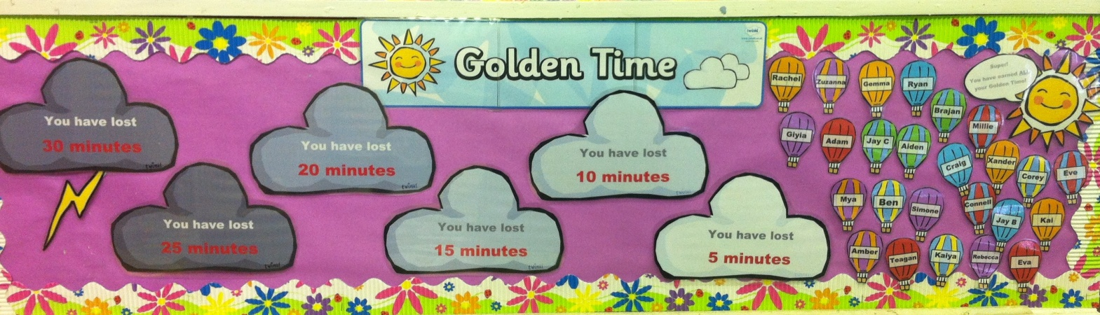

To stay in the 30 minutes, pupils are to follow the 5 school rules.

All classes have the warning card system in place to follow. This warning system links to the Golden Time chart and determines when a child will lose Golden Time.

If a child is following the school rules they stay in the green face and they are on their way to Golden Time.

Should a child choose not to follow the rules or make inappropriate behaviour choices they will be given a warning. When this happens the child then moves their name to the amber face. Pupils need to work a little harder here to remember and follow the rules.
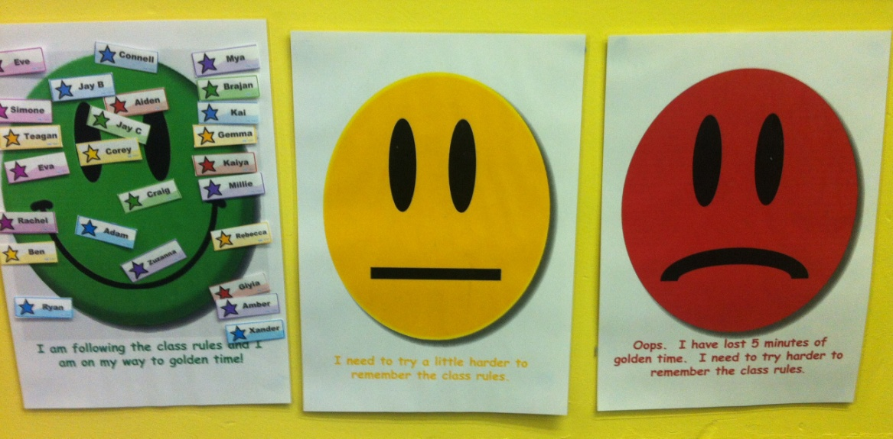

If a child continues not to follow the school rules when they are on an amber face, they need to move their name to the red face. This means that the child has lost 5 minutes of their Golden Time.

At the beginning of each new school day and after each break in the school day, each child’s name will move back to the green area of the warning chart. This ensures that at each opening of the school day every child is given a fresh start.

The aim is for each child to stay within the ‘golden area’ of the main Golden Time chart so that they keep all of their Golden Time.

Any child who loses Golden Time during the course of the Golden Time week goes to the Head Teacher for a time of reflection during the Golden Time session. Pupils are encouraged to reflect on why they have lost Golden Time and what they can do differently in the coming week. Pupils complete this task for the duration of time lost.

For the remainder of the Golden Time session pupils can participate in a quiet individual or paired activity.

This is a whole school approach that intends for pupils to make positive choices regarding their behaviour in school.

Celebrating Success – The End of Term Treat!

Pupils who have kept all of their Golden Time or not lost more than 10 minutes of Golden Time in any one given week, participate in the Golden Time Treat. The Golden Time treat takes place at the end of each term and is a celebration where pupils can take part in different activities e.g. cuddle down movie time, visiting the local park for a series of games and play, giant bouncy castle for each class. This is a time that both pupils and staff look forward to as a time where positivity can be rewarded and celebrated by all.

