Visible Learning
St. Luke’s RC Primary School
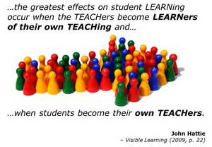

Parent Information Booklet

2016/2017
What is Learning?

Visible Learning is an approach to learning and teaching. It is based upon a large amount of evidence from American research John Hattie. He was interested in the factors which impact positively upon teaching and learning and in turn, the factors which raise attainment. Here are some of the key ideas from the Visible Learning research:

- The whole school community should have a shared language of learning.
- Learners should be at the centre of a Visible Learning approach surrounded by inspired and passionate teachers.
- When learning is made ‘visible’ (teachers know what they are teaching and learners know what they are learning), achievement increases.
- A visible learning approach supports pupils to become assessment capable learners who know where they are in their learning, where they are going next and how they are going to get there.
- Effective feedback is crucial – it should be personal for each child and ‘just in time’.
- The greatest effects on learning come when pupils are their own teachers and when teachers and learners.

What does Visible Learning Look Like?
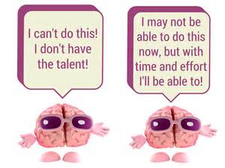

Mindsets
Pupils have already been learning about growth and fixed mindsets during the 2015/2016 session. A fixed mindset is when we believe we are born with a fixed intelligence and that this cannot be changed or improved. A growth mindset is when we believe we are born with a changeable intelligence that can continuously improve as we engage with different learning experiences and develop new skills.
Pupils are encouraged to change their learning apprach from a fixed mindset to a growth mindset by believing they can achieve. When we hear ourselves saying “I can’t do this!’ We will change the statement to:
I Can’t do this...YET!!!
Mistakes

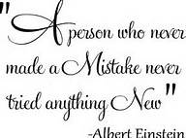

Pupils have explored mistakes as opportunities for learning and have shared their mistakes confidently with their peers. The culture of mistakes being a good thing is being continuously promoted throughout the school. Pupils can use their mistakes to develop their ability by recognising what needs to change the next time they attempt the same or a similar skill.
Thinking about Thinking

A meta-cognition, or thinking about thinking, focus will encourage children to talk about their learning and discuss their thinking when solving problems and finding solutions. Pupils will learn about parts of the brain. They will learn that the brain can grow and make new connections when you learn new things or take on new challenges.

The Language of Learning
Pupils will investigate the language of learning over the 2016/2017 session. Each week we will focus on the meaning of a new word and what it means for us and our learning. Pupils will across stages to design and create mascots for each of the learning words:

Concentrate
Perseverance
Cooperate
Explorer
Resourceful
Reflective
Imaginative
Resilient

The Learning Pit

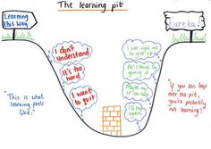

The Learning Pit is an imaginative way to help pupils with their learning. It helps children understand that challenge is a good thing and supports pupils to develop strategies for when they are stuck in their learning both in and out of school.

How can I support my child at home?

To support our work in school on developing a language of learning, we would encourage you to discuss learning at home too. Here are some ideas of questions you might like to use at home:

- What was the best thing that happened at school today?
- Tell me something that made you smile at school.
- Tell me about something you learned or something you did.
- Was there anything you found really tricky? What strategies did you use to help you in your learning?
- Tell me one thing you learned at school today and I’ll tell you one thing I learned today.
- What’s your favourite thing about your teacher?
- What are you working on in Art/Music/PE class?
- What are you looking forward to at school tomorrow?
- Did you make any mistakes at school today? Tell me what you learned from them.
- What challenged you most today?
- What was the nicest thing you did for someone else today?
- Do you have any questions that maybe your teacher could answer?

Follow us on twitter @stlukesps1
Look for school updates with hashtag #VisibleLearning
You can also keep up to date on our website: www.stlukes.mgfl.net

