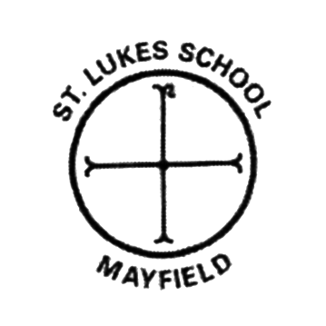
Reflect
Resilient
Perseverance
Imagine
Explore
Co-operate
Resourceful
Concentrate
We Believe We Achieve

We are committed to our families, our community and our parish to enrich the lives of every child in our care.

For all in our school community to believe that we can achieve we aim to:
- Inspire belief within ourselves
- Challenge ourselves and realise our own and others potential
- Create an ethos of trust and respect
- Celebrate our individuality and heritage

“Let the children come to me, and do not hinder them, for to such belongs the Kingdom of God.”
Luke 18:16

