St. Luke’s RC Primary School

Safeguarding and Child Protection Procedures

Session 2016.2017

Child Protection and safeguarding of pupils must be seen within the wider context of supporting families and meeting children’s needs through the principles of GIRFEC.

These principles
- Put the needs of children first
- Ensure that children are listened to and understand decisions that affect them
- Ensures that children receive appropriate co-ordinated support needed to promote, support and safeguard their wellbeing, health and development

This ensures the welfare of the child is paramount.

GIRFEC requires that all services for children and young people, and adult services working with parents and carers of children and young people – including social services, health, education, police, housing and third sector services – adapt and streamline their systems and practices so that, where necessary, they can work together better to support children and young people.

Professionals working with children are required to work together to share information, assess needs and risks, and plan and deliver services jointly in a co-ordinated manner. In doing so, professionals can reduce the risk of harm to children and also promote their welfare.

This approach encourages earlier intervention by practitioners to avoid crisis situations at a later date and ensures that children and young people get the help they need when they need it.

These principles, enshrined in legislation and practice in child protection, are derived from Articles of the UN Convention on the Rights of the Child, ratified by the UK Government and endorsed by the Scottish Government. These principles include:
- each child has the right to be treated as an individual;
- every child who can form a view on matters affecting them has the right to express those views if they so wish, and those views should be given due weight in accordance with the child’s age and maturity
- parents should normally be responsible for the upbringing of their children and should share that responsibility
- each child has the right to protection from all forms of abuse, neglect or exploitation
- insofar as is consistent with safeguarding and promoting the child’s welfare, public authorities should promote the upbringing of the children by their families, and any intervention by a public authority in the life of a child must be properly justified and should be supported by services from all relevant agencies working in collaboration.

At St. Luke’s Primary School all staff, including office, janitorial, catering and cleaning staff will be trained and updated in Child Protection Awareness Raising and Response, which will include an update on Child Protection and Procedure by the Midlothian Council Child Protection Officer every two years. This training will include updates on categories of abuse and understanding of risk factors for children.

An annual refresher on child protection protocol is completed at our in-service in August. Staff revisit child protection procedures and what to do in the event of a disclosure at this time. In August, the senior leadership team meet with teachers individually to discuss specific pupils. This may occur again throughout the school year, as situations arise.

All staff are expected to use the GIRFEC Wellbeing Concern form to identify concerns for children. These concerns should be given to the head teacher.

Child Protection procedures in school follow the ‘Edinburgh and Lothians Inter-Agency Child Protection Procedures 2015.’

This document is located in paper format in the Head Teacher’s office in a file marked ‘Child Protection Guidance.’ This document is also located on the school server in a digital format, in a folder marked ‘CP Guidance.’

The Midlothian contact numbers for Child Protection are available in all rooms within the school. There are laminated copies on the wall in the Head Teacher office and the main school office.

All rooms in the school have a ‘W Question’ card supporting all staff members should a disclosure occur, ensuring correct procedures take place.

The Head Teacher is the designated member of staff for our school. In her absence a member of the senior leadership team should be consulted. Please consult guidance procedures to ensure correct procedures are followed.

If a staff member is unsure if a disclosure is a child protection issue, our school procedure is to contact duty social work to voice our concerns and to ask for advice. The Head Teacher will support staff members in making a call to Social Work.

School Procedure
The initial response of staff toward suspicion of abuse is critical.

- No guarantee of confidentiality can be given to the child or person raising the concern. They will be informed that as a minimum the matter must be recorded and will be discussed with other staff with responsibility for child protection

- Initial questioning must be limited to establishing basic facts

- Staff will not introduce personal experiences of abuse or those of others

- The matter must be immediately referred to the member of staff with responsibility for Child Protection or, in their absence, a senior member of staff or passed on to one of the Core agencies (Social Work, Health, Police)

- Where no such person or senior member of staff is available then staff must refer the matter directly to one or more of the Core Agencies without delay

- If suspicions arise because of something a child has said the member of staff will record the facts as accurately as possible using the child’s own words, noting questions asked of the child and responses obtained. This will be signed and dated on the same day and a copy retained

- Staff will record the time/date they pass their concerns to the member of staff with responsibility for Child Protection/Senior staff member

- Staff will record the time/date of any referral made to one of the Core Agencies, to whom the referral was made, any decisions/advice and the time of any response from the Core Agency

- The member of staff will ensure security of any records kept

Initial Questioning

Anyone who receives a ‘disclosure’ of possible abuse directly from a child or observes circumstances that
cause them concern may try to establish the basic facts before referring the matter further.

It is crucial that this initial fact finding does not influence what the child says; therefore, the following
strict guidance is given in regard to the initial questioning of children:

- Only ask enough questions to gain basic information

- Take the disclosure seriously and offer support

- Avoid leading questions

- Use open-ended questions

To Establish… | You could ask… | Don’t ask
What | What happened? | Did he/she .....?
Where | Where did it happen? | Did he/she come to your bedroom?
Who | Who did it? | Did daddy/baby-sitter/John do it?
When | When did it happen? | Did it happen last night?
How/Why | Avoid these questions, they require judgement from the child and may induce self  blame

The Procedures are designed to ensure that when a child makes an allegation or disclosure, all involved follow the same procedures. These are listed below and are designed to ensure that the child is given the opportunity to talk with an adult he/she trusts.

The following is designed as a quick reference to help staff when a child makes an allegation. However it is essential that all staff become aware of the Edinburgh and Lothians Inter-Agency Child Protection procedures.

A Child Makes an Allegation

Step 1 Take the child to a quiet place. Ask for immediate cover for your class.

Step 2 Listen.

Step 3 Reassure the child that you know it is not his/her fault.

Step 4 Reassure the child that you are sorry about what has happened.

Step 5 Do not show disbelief.

Step 6 Do not give a guarantee of secrecy.

Step 7 Take the allegation seriously.

Step 8 Affirm the child’s feelings.

Step 9 Refer to the Head Teacher.

Remember when responding to the child - ask open ended questions:

When? Where? Who? What?

Appendix 2 GIRFEC Wellbeing Concern Form

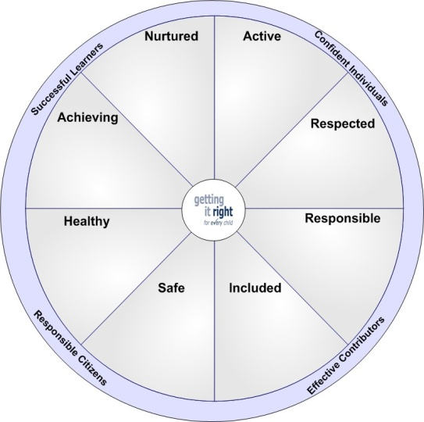

ESTABLISHMENT: St Luke’s PS DATE:

RECORD OF PUPIL WELLBEING DISCUSSION (Midlothian Stage 2)

Full Name |  | Date of Birth
School Name | St Luke’s PS | Referrer
Named Person |  | Staged Intervention | 1 2 3
Allocated C&F Worker |  | Previous PCM/ 0-12 Forum discussion | Yes NO
Lead Professional |  | Parental Consent Received | Yes No
Family Address |  | Family Name

Summary of concerns arising from information held including historical /Supports currently in place
Wellbeing Indicator
Summary points of Discussion

Action |  |  | By Whom | By When
 |  |  |  | 12
Continue to monitor | YES / NO | Gather more information |  | YES / NO
Contact Lead Professional | YES / NO | Organise multi-agency assessment & planning meeting

